**Task 1: Sales Performance Analysis**

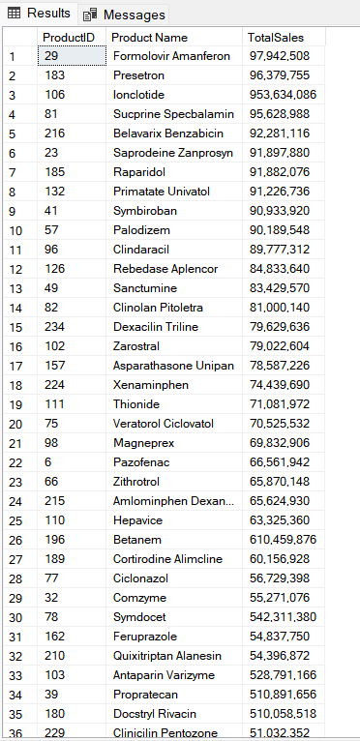**Total sales for each product (Top-selling products)**

**Monthly sales trends within a specific year (2019)**

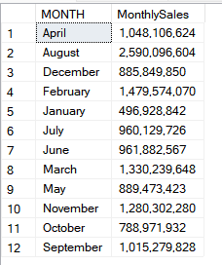

**Task 2: Sales by Location**

**Top cities by sales volume**

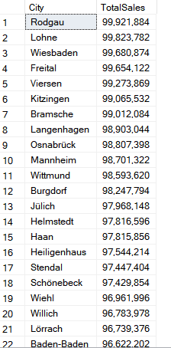

**Sales performance by country**

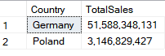

**Task 3: Customer Segmentation**

**Total sales by customer type**

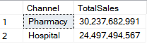

**Sales comparison across sectors**

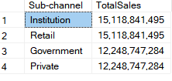

**Task 4: Product Analysis**

**Top-selling products within each drug class**

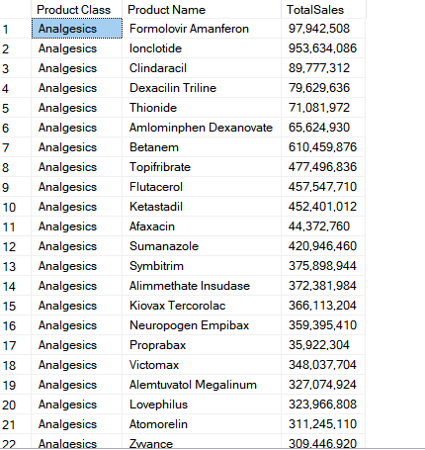

**Average price for each class of drugs**

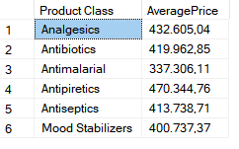

**Task 5: Sales Representative Performance**

**Top-performing sales representatives based on total sales**

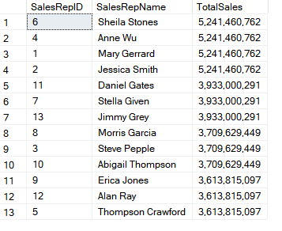

**Sales performance across different sales teams**

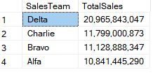

**Task 6: Time Series Analysis**

**Year-over-year growth in total sales**

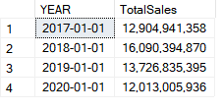

**Months with consistently high sales volume**

